Inertial Values:

* Transmission Inertia: 222 Kg/(m^2)
  + Source: See ZF Transmission Drawing
* Propeller Inertia: 216 Kg/(m^2)

To

Assumptions:

-Cooling and all support loads are approximately equal between systems and removed from consideration

Assumed values and rational:

**Variable Frequency Drive Efficiency:** https://www.nrcan.gc.ca/energy-efficiency/energy-star-canada/about/energy-star-announcements/publications/variable-frequency-drives/application-considerations-and-estimated-savings-for-vfd-drives/15385

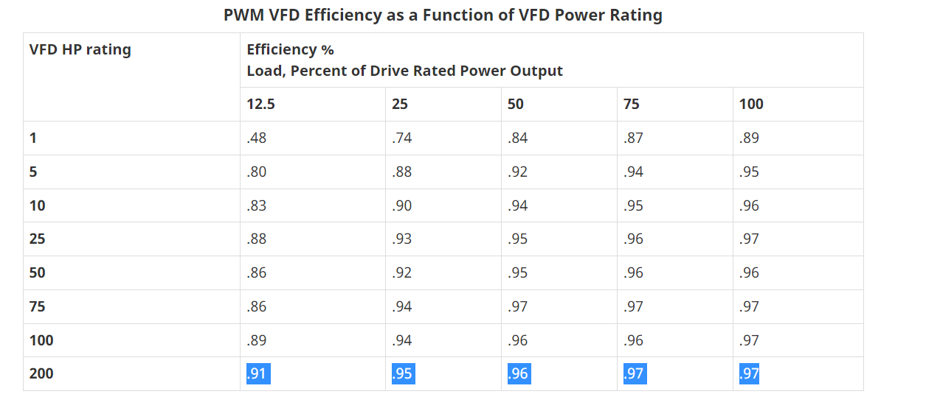

Conventional System Sizing:

Hybrid System Sizing:

Full Electric System Sizing: